Station 60: 35100 Pacific Highway S., Federal Way

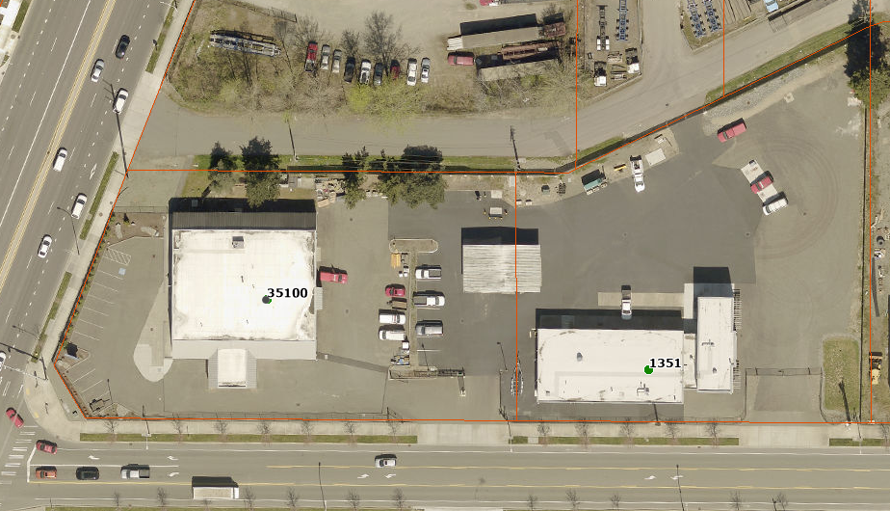

Station 61: 3203 S 360th Street, Auburn

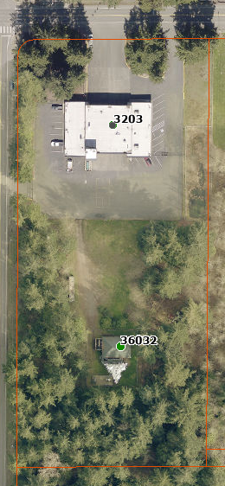

Station 62: 31617 1st Avenue South, Federal Way

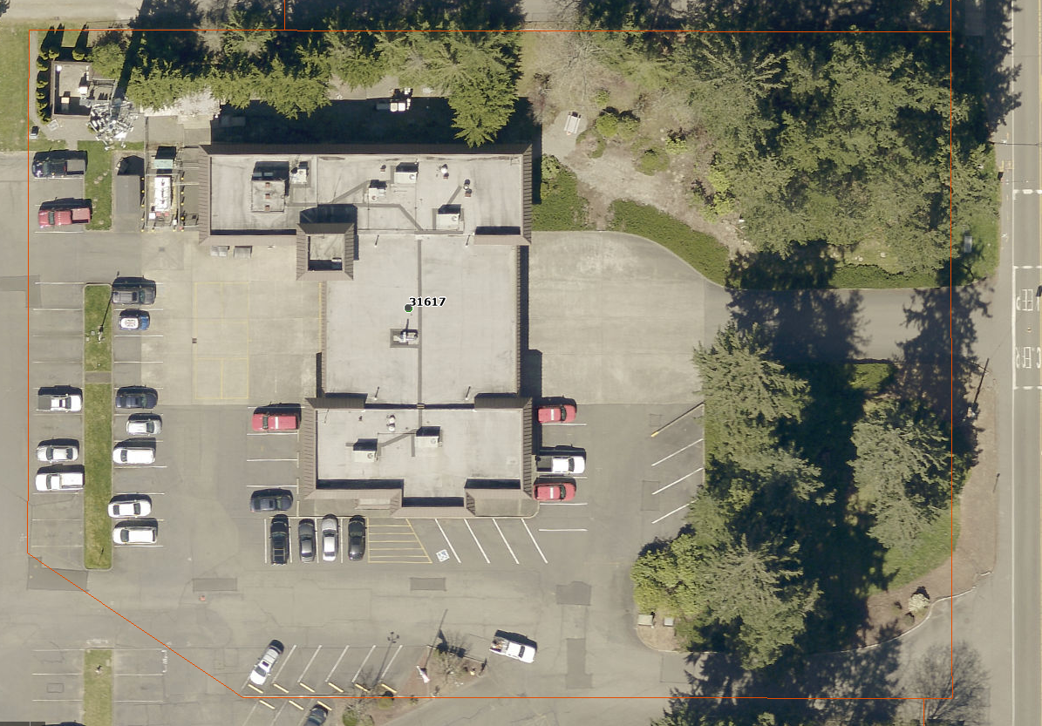

Station 63: 33414 21st Avenue SW, Federal Way

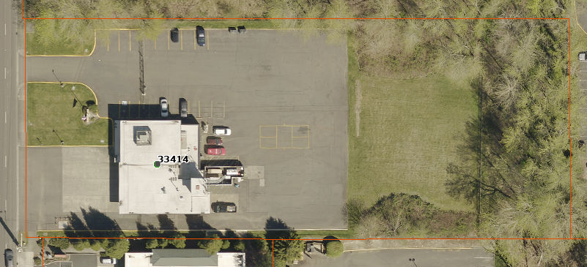

Station 64: 3700 S 320th Street, Federal Way

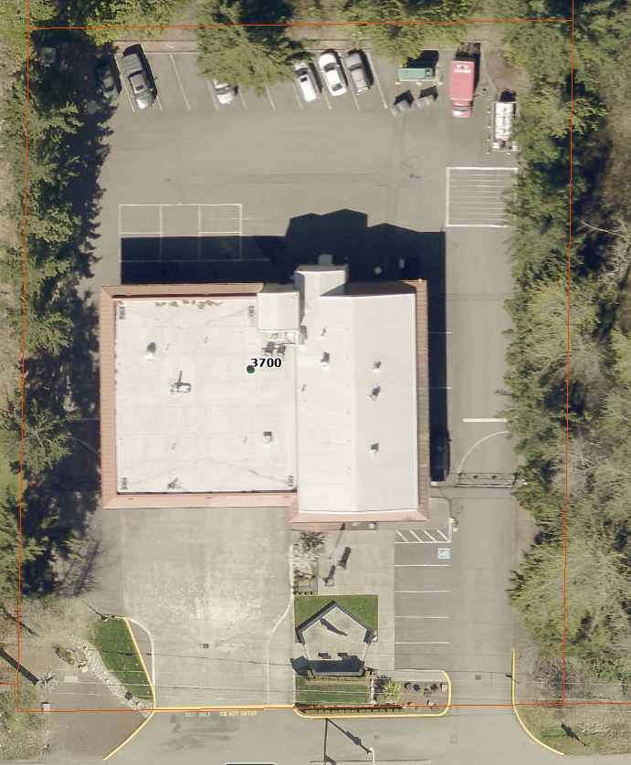

Station 65: 4966 S. 298th Street, Auburn

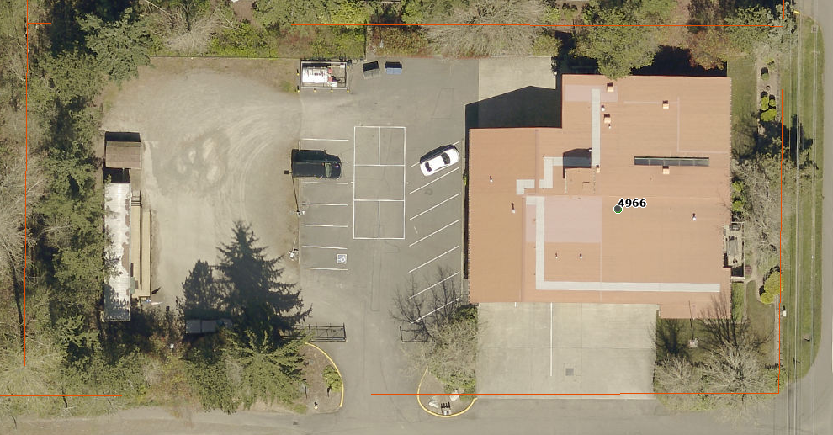

Station 66: 27010 15th Avenue S., Des Moines

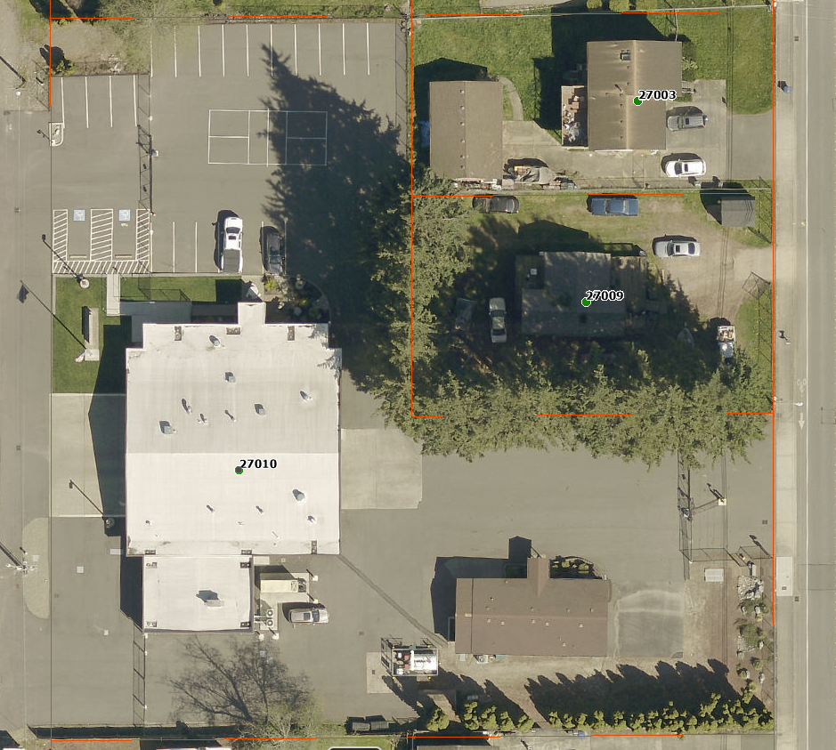

Station 67: 2238 S. 223rd Street, Des Moines
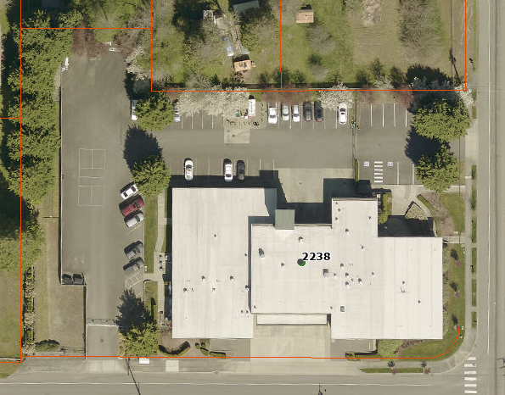

Station 68: 1405 SW 312th Street, Federal Way

