Fire Benefit Charge (FBC) Frequently Asked Questions
- What is the Fire Benefit Charge (FBC)?
South King Fire is proposing to adopt a more stabilized funding approach that distributes costs for the delivery of fire protection services, known as The Fire Benefit Charge (FBC).
The FBC is not a tax. Instead, it is a fee that aims to place more cost on structures with higher fire risk and resource needs, and less cost on those with lower risk or resource needs.
Smaller structures (such as single-family homes) generally pay less than larger buildings (i.e. commercial buildings) because it takes fewer resources to protect them in a fire.
If the FBC is approved, it will lower regular property tax rates and eliminate the need for a renewed Maintenance & Operations levy. This will create a more stabilized funding approach that relies less on property tax, which can be subject to fluctuations.
- Does the FBC require voter approval?
Yes. South King Fire will be placing the FBC on the August 6, 2024, ballot. To initially implement the FBC, it requires a 60% majority vote.
- What happens if the FBC is approved? When would it take effect?
If voters approve, the FBC would be in place for six years (2025-2030). It initially requires a 60% majority vote.
After the initial approval (six-year term), voters would decide whether to reauthorize the FBC. Extending it for an additional six or ten years requires a simple majority vote, whereas a permanent extension requires 60% voter approval.
- Why is South King Fire seeking the FBC?
Due to population growth, higher density and community need, additional resources and services are required to meet rising demand. In 2012, South King Fire responded to 16,279 emergency 911 calls. Fast forward to 2023, emergency 911 calls now exceed 25,000 annually, signifying a 54% increase compared to a decade ago.
This rising demand in emergency response calls is creating conditions that are:
- Unsustainable, surpassing what our current funding structure can support.
- Negatively impacting response times and resource availability.
In order to uphold fiscal responsibility and effectively meet the rising demand for emergency calls and fire services, South King Fire is proposing a new, more stabilized funding model, called the Fire Benefit Charge.
- Have other communities supported the FBC?
Communities in other fire districts in Washington state have supported the FBC, dating as far back as 2003. Fire districts include Central Pierce Fire & Rescue, Graham Fire & Rescue, King County Fire District 40, Puget Sound Regional Fire Authority (Kent), Renton Regional Fire Authority, Valley Regional Fire Authority (Auburn), and Woodinville Fire & Rescue.
When emergency services are funded solely on a property's assessed value, it can lead to two properties of similar size being charged differently depending on location/property value. However, the expense of defending them against fires is likely the same. The implementation of a fire benefit charge, determined by property size and fire risk, is regarded as a fairer approach to funding emergency services.
- How does the approval of the FBC affect how South King Fire is currently funded? How would the FBC affect me as a property owner?
South King Fire’s current funding model relies heavily on property taxes that include the fire levy and the Maintenance & Operations (M&O) levy. The FBC will create a more stabilized funding approach that relies less on property tax, which can be subject to fluctuations.
Funding with the FBC would result in:
- A reduction in the fire levy collection from the current $1.50 to no more than $1 per $1,000 of assessed property value. Such a reduction is required by law.
- The expiration of the current Maintenance & Operations (M&O) levy at the end of 2024.
- The district not seeking a replacement multi-year M&O. Voters have historically approved M&O’s every 4 years (2012, 2016, & 2020)
- How is the FBC calculated?
The FBC is calculated using a formula that considers key factors such as the square footage of structures (i.e. buildings), and for commercial properties, any additional specific hazards.
There are four property types:
- mobile homes
- single family
- commercial
- multi-family
- What is the FBC formula?
FBC = (Square Root of the *Square Footage x 18) x Use factor x Cost/Gallon x Discount
The Insurance Services Organization (ISO) established the first part of the formula (square root of the square footage times 18) as a mathematical method to determine the required fire flow for a given structure. Additional adjustments are made based on a “Category Factor” and a “Fire Flow Benefit Factor”. This calculation method determines the specific fire benefit charge applicable to each parcel of property.
- Category Factor – The category factor is based upon building use and size (residential, mobile homes, apartments, commercial). This information is obtained from the King County Assessor database for each building subject to the benefit charge.
- Fire Flow Factor – The relative cost of providing the required fire flow per gallon during a fire incident.
- Effective Response Factor – The effective response force factor is relational to the size of force in firefighters and equipment required to deliver the required fire flow.
- Hazard Factor – The hazard factor represents the degree of risk caused by the use, processing, or storage of hazard materials with a building. The hazard factor reflects the need for larger and/or more specialized effective response forces. Hazard factors are determined from use and risk classifications found in the National Fire Protection Association (NFPA) Standard 13 (Standards for the Installation of Sprinkler Systems), and are applicable to commercial properties only.
- Extra Hazard Charges are as follows:
  - a. A 15% increase for automotive fueling stations, general retail stores, eating and drinking establishments and light industrial/commercial buildings.
  - b. A 20% increase for big box retail, automotive fueling, repair, and service facilities.
  - c. A 30% increase when products or uses with high combustibility or high rates of heat release are present.
  - d. A 40% increase when products or uses with high quantities of flammable, combustible or hazardous materials are present.
  - No surcharge will be assessed on light hazards.
*Note: Square footage includes total square footage of all structures including carports, garages, unfinished basements and certain outbuildings.
- Where does the fire district get information about the size of structure(s) on my property to assess the FBC?
Property information is obtained directly from the King County Assessor’s Office.
- How is the FBC collection established? Is there a limit?
After the Board of Commissioners sets the fire department's yearly budget, they calculate the total FBC collection needed. This sum is then fairly distributed among properties expected to benefit from the District’s services.
For 2025, the FBC is estimated to be 36-38% of the District’s operating budget. This percent range is based on projected King County property values.
By law, the revenue collected from the FBC may not exceed 60% of the fire district’s operating budget.
- How is it that some property owners, such as those in single family homes, may pay less under the funding approach with the FBC?
With the FBC, the fee is based on a formula that calculates property size, use, risk, and other hazards. Smaller structures (such as single-family homes) generally pay less than larger buildings (i.e. commercial buildings) because it takes fewer resources to protect them in a fire.
Here are some examples:
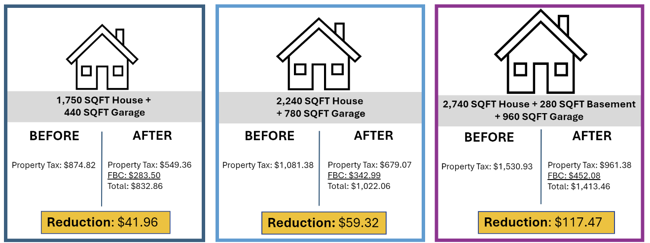
**These property tax estimates are based off of 2024 collections according to King County's assessed values.
FBC rates are estimated using King County's Assessed Value (AV) projections for 2025.

- Where would I see the charge for the FBC? How is payment collected?
If the FBC is approved, it would be collected by the King County Assessor-Treasurer’s Office. When property owners receive their statement from King County, they would see the FBC under the category that is usually identified as "Fire Fee".
- What happens if the FBC is not approved?
With the escalating demand for emergency services and the current funding model, South King Fire would need to find ways to address budget shortfalls, which could involve seeking additional property taxes or reevaluating service delivery models. If the FBC is not approved:
- The primary funding source from property tax levies would remain at or up to $1.50 per $1,000 of assessed value.
- South King Fire would experience an immediate annual budget shortfall of $3.75M per year due to the expiration of the current M&O levy at the end of 2024. The loss of revenue would require significant budget cuts, impacting levels of service and response times.
South King Fire would need to place another multi-year Maintenance & Operations levy on the ballot in 2025 to balance the budget and maintain service levels.
- Are there discounts?
Low-income seniors or disabled persons that qualify for property tax discounts will receive the same percentage discount on the FBC. These discounts are administered through the King County Assessor’s Office. Only King County can grant the discounts.
For more information on qualifications, please visit King County’s website here.
- What if after the FBC is approved, I disagree with the FBC that has been assessed to my property?
A notification letter is mailed to property owners each year after benefit charges have been established. The letter will specify the FBC amount assessed for the year, the square footage data used for the calculation (based on data from the county), and information about the appeals process.
- What does the FBC pay for?
The FBC would pay for general operating costs such as staffing, emergency response equipment and supplies, facilities maintenance, and other resources.
- Who do I contact for questions?
We are here to help answer your questions. Visit our website at www.southkingfire.org, call us at 253-839-6234 or email fbc@southkingfire.org.
For interpretation in other languages, call 253-839-6234.

RCWs pertaining to the Fire Benefit Charge can be found here: https://app.leg.wa.gov/RCW/default.aspx?cite=52.18

