SOUTH KING FIRE & RESCUE
KING COUNTY, WASHINGTON
RESOLUTION NO. 320
A RESOLUTION of the Board of Commissioners of
South King Fire & Rescue, King County, Washington, Establishing Meal Per Diem and Mileage Expenses
For District Personnel
WHEREAS, it is sometimes necessary for District Personnel to travel to conduct District business, attending meetings, or attending educational classes, and
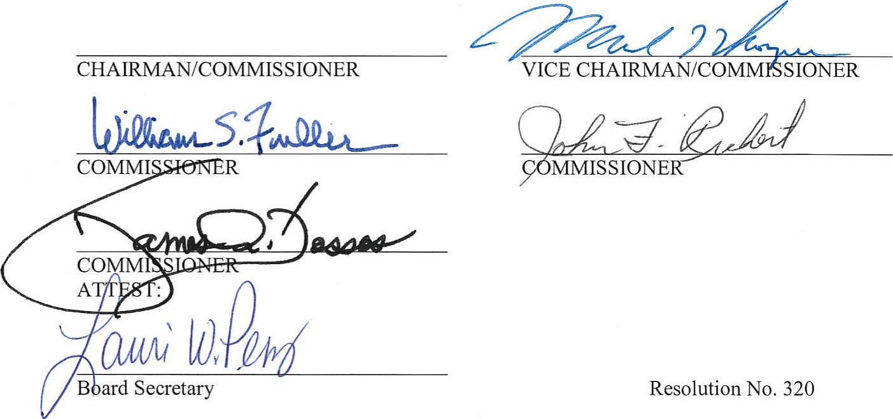
WHEREAS, during such travel the individual will incur expenses for meals and, if required to use their own vehicle, mileage expense, and
WHEREAS, if District Personnel are required to use their own vehicle, the District will use actual odometer readings, Mapquest.com and/or AAA to determine the reimbursable mileage, and
WHEREAS, the District has an obligation to reimburse such personnel for reasonable expenses incurred while acting on behalf of the District.
NOW, THEREFORE, BE IT RESOLVED that a reasonable sum to be allowed personnel for mileage and per diem allowances has been established by the District (in accordance with IRS guidelines) and is set forth on the attached schedule, the schedule is updated per the IRS recommended per diem and mileage reimbursement on a yearly basis or a special adjustment.
ADOPTED by the Board of Fire Commissioners of South King Fire & Rescue, King County, Washington, at a regular meeting this 23 ^{rd} day of January 2018, with the following Commissioners being present and voting.

STATE OF WASHINGTON
TRAVEL REIMBURSEMENT RATES

Update to Resolution 320 Effective 1/01/2018
 |  | MILEAGE |  |  | MEALS
BASIC RATE  HIGH COST AREAS: |  | .545 |  |  | $51.00
Everett/Lynnwood |  |  |  |  | $64.00
Ocean Shores |  |  |  |  | $69.00
Olympia/Tumwater |  |  |  |  | $69.00
Pasco |  |  |  |  | $59.00
Port Angeles/Port Townsend |  |  |  |  | $74.00
Richland |  |  |  |  | $59.00
Seattle |  |  |  |  | $74.00
Spokane |  |  |  |  | $64.00
Tacoma |  |  |  |  | $64.00
Vancouver |  |  |  |  | $64.00
*Meal Rates | TOTAL  $51.00  $54.00  $59.00  $64.00  $69.00  $74.00 |  | Breakfast  $12.00  $13.00  $14.00  $16.00  $17.00  $18.00 | Lunch  $14.00  $15.00  $17.00  $18.00  $19.00  $20.00 |  | Dinner  $25.00  $26.00  $28.00  $30.00  $33.00  $36.00

